Explaining the code in sections

## Section 1:

For the first section, the code imports the two libraries needed to make the program work. The requests library allows python to get information from the internet such as the html code or a file. BS4 and Beautifulsoup grabs the html code from a website and makes it python friendly which can be analysed and read through via the html parser. I have also created a new variable called result, where it finds all of the html tags with ‘td’ and the class as ‘instrument’ as this allows for all the instrument names to be identified. There is also an instrument count to count the number of instruments that have been found. All instrument names are put into a list called instruments.

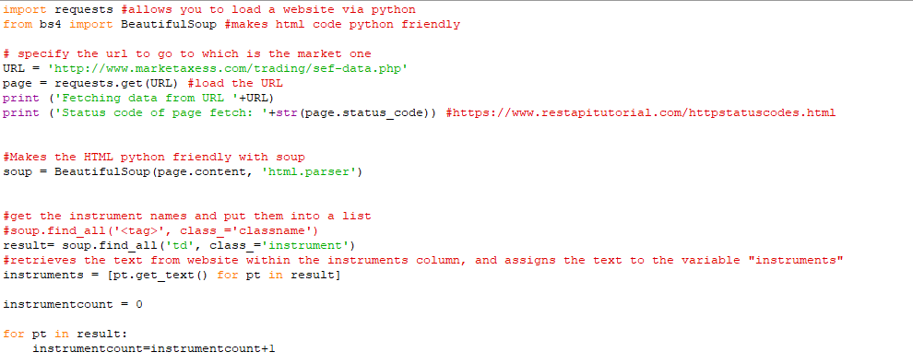

Outputs:

This is what the instruments list looks like:



The output of the page status and the URL where data is being grabbed from:



## Section 2:

Within section 2 are where all of the volumes from within the html code are identified. However, the website did not correctly class or identify the volumes properly, so all items with the tag of ‘td’ are put into the volumes list. This will be seen in the volumes list in the output. However, I did manage to correct this by multiplying the number by 5 as every 5 items contained the volume for each instrument.

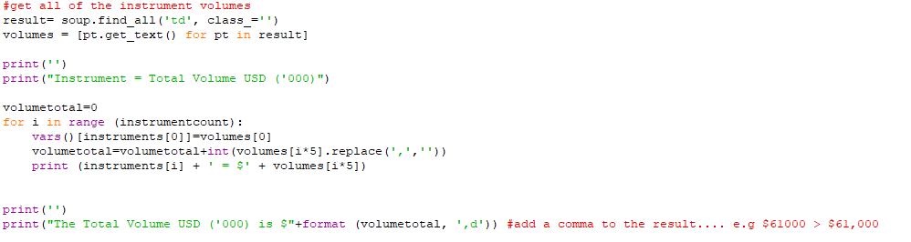

Outputs:

This is what the volumes list looks like:

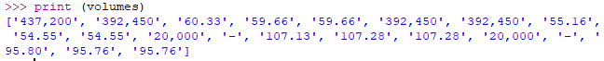

The total is outputted with the correct volume as seen below:

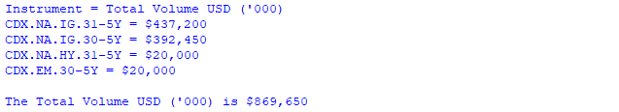

## Section 3:

Within this section is where the results are written in an excel spreadsheet. This is achieved using the xlwt library and the workbook function that lets you create and write a workbook that can be opened by excel. The .write function from the xlwt library allows you to write to the sheet that has been created and list all of the instruments within it.

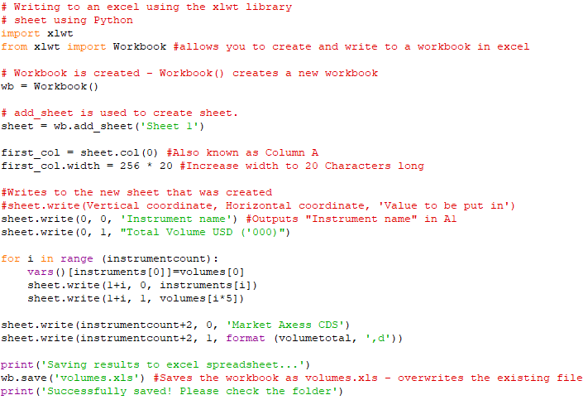

Outputs:

The outputs from within python are:



